Energy
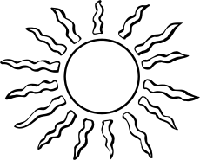
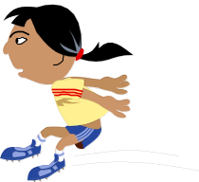

What is energy?


Energy is something that is needed to make things happen. Without energy there would be no movement and no change. Scientists say that energy is the ability to do work. For example, we know a
moving car has energy because if it crashes into a fence it can knock the fence down.

1. Carry out experiments with the following objects to show that they possess energy. Describe how you showed each object possessed energy.

Object | How did you show it possessed energy?
a dry cell

water flowing from a tap

a blown-up balloon

a moving marble

a mixture of natural gas and air

a magnet

a stretched elastic band

a charged perspex rod

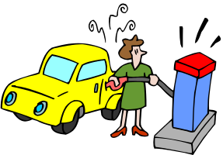
Sources of energy

There are many different ways that energy can be made available for us to use.
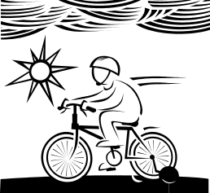
For example a car gets energy from burning petrol in its engine, and
when you ride a bike, the energy comes from the muscles in your
body, and your muscles get energy from the food you eat.

2. Devices we use every day need energy to work. For each device listed below, state what it is
used for and where it gets its energy from. The first example has been done for you.
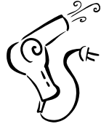


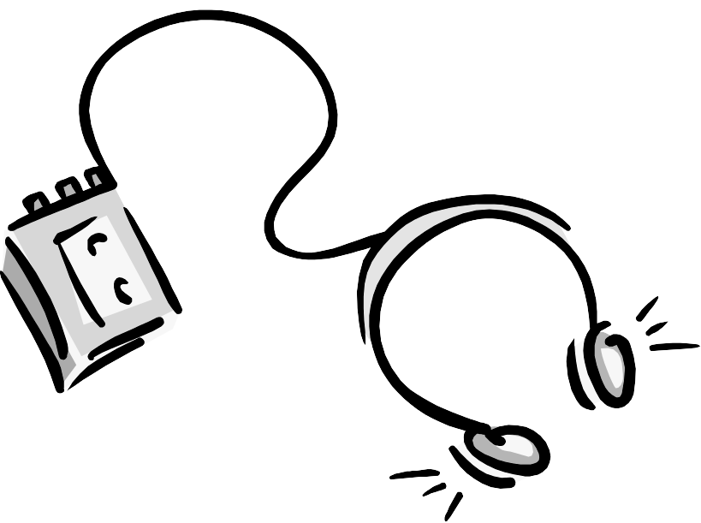
Device | Use of device | Where energy comes from
radiator | to heat people | electricity
hair dryer
solar powered calculator
Bunsen burner
portable radio
bed lamp
farm windmill

Natural energy sources in use today are often classified as renewable or nonrenewable. Renewable energy sources will also be available or can be replenished in a short period of time, while non-renewable sources take millions of years to form and their supplies are limited.

3. Some natural sources of energy are listed in the table below. Identify each as a renewable energy source or a non-renewable energy source and also list several ways in which we use the energy from the particular source.
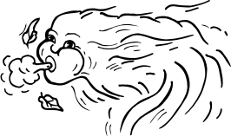

Natural source of energy | Renewable or non-renewable? | Ways in which we use the energy.
Sun

Wind

Oil/petrol/natural gas

Plants

Nuclear reactions

Geothermal sources


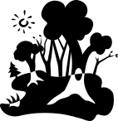

3. Why are oil, coal and natural gas called fossil fuels?

4. Where did the energy in fossil fuels originally come from?
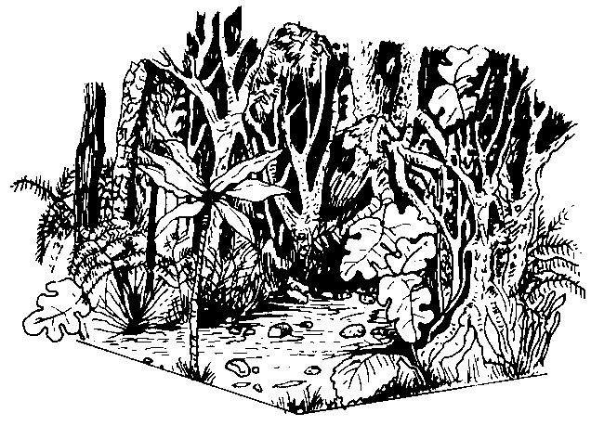
5. Why are fossil fuels considered to be non-renewable sources of energy?

Different forms of energy

There are two main types of energy: potential energy (stored energy) and kinetic energy (motion or active energy), which have many different forms, as shown below:

Energy
Kinetic
energy
(active or motion energy)
Gravitational energy

Chemical energy

Elastic energy

Nuclear energy

Magnetic energy

Light (radiant) energy

Heat energy

Sound energy

Electrical energy

Potential
energy
(stored energy)

6. Complete the boxes in the diagram on the previous page by

i) writing a description of each different form of energy. Choose your answers from the list given below.

ii) drawing a picture of an object which possesses or is a source of each form of energy, for example, a hair dryer is a source of heat energy
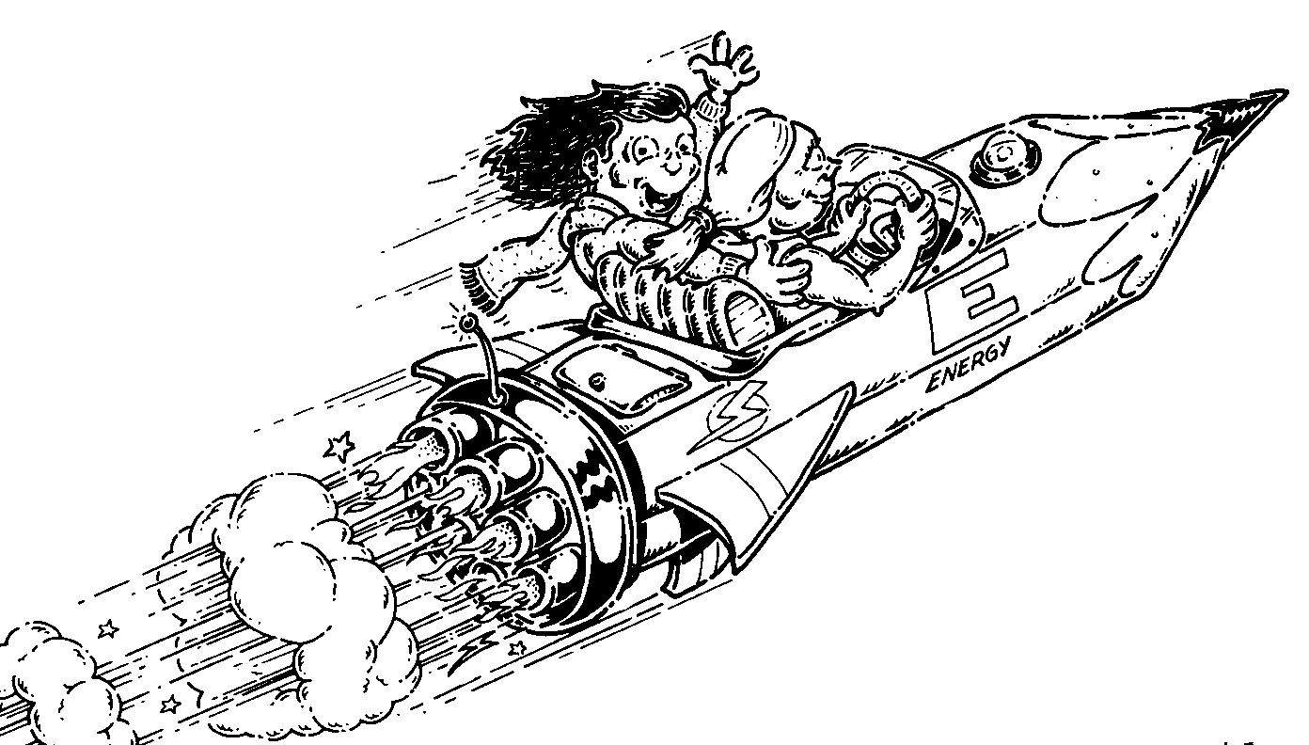
Energy Descriptions  stored in stretched objects  stored in raised objects
⬧ produced by luminescent objects  produced by vibrating objects
⬧ possessed by magnets and magnetic objects  increases movement of particles
⬧ possessed by flowing electrons  stored in foods and fuels etc
⬧ contained in nucleus of an atom

Energy changes

Energy can change from one form into one or more other forms i.e. energy can be
transformed. Energy can also move from one place to another i.e. energy can be transferred.

7. Carry out the following experiments and for each state the initial type of energy and the type or types of energy it has been changed into.

Experiment | Initial type of energy | "Final" type(s) of energy
1. Place a dark coloured object in the sunlight for
15 minutes
2. Turn on an electric radiator

3. Strike the tuning fork

4. Release a stretched rubber band

5. Hold a ruler on the edge of a desk and strike
the "free" end of the ruler
6. Connect up a cell and light globe in an electric
circuit
7. Burn a piece of magnesium ribbon

8. Run a toy car down a sloped surface

9. Allow a candle to burn

10. Hold the aluminium foil coil above the
burning candle
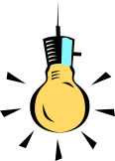

8. Fill in the correct form of energy in each of these blanks:
a) A TV set changes ............................... energy to ................................. and .................................. energies.

b) A light bulb changes .............................. energy to .................................. and............................ energies.
c) An electric kettle changes ........................................ energy to .................................... energy.
d) A helicopter changes ....................................... energy to ............................................ , ................................... and ........................... energies.
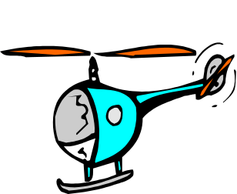
e) An atomic bomb changes ........................................ energy to ....................................... , ................................... and ............................ energies.
f) A portable radio changes .............................. energy into .................................. and ....................... energy.


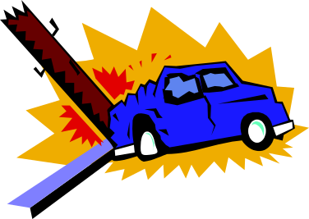
9. Use an energy flow diagram to describe the energy changes/transfers that take place when

a) you throw a ball in the air and it falls to bounce off the floor

b) using an elastic band, you flick a piece of paper at someone

c) a car moving along a road, hits a light pole

Conservation of energy

The law of conservation of energy states that energy can not be made or destroyed. Energy can only be converted from one form to another. This means that the universe always has the same amount of energy, even though this energy is constantly being converted from one form to another and being transferred from one place to another.



